

Year 11 ATAR Chemistry 2024

Test 2 – Moles, Rates and Energy Changes

Weighting: 3.75%
Time: 50 min

Marks: / 55 %

Name___________________________________

Section A: Multiple Choice (10 marks)

This section has 10 questions. Answer all questions by circling the correct option. Marks will not be deducted for incorrect answers. No marks will be given if more than one answer is completed for any question.

Suggested working time: 10 minutes

1. Select the option where the formulas for the three named ions are given correctly.

nitrite cyanide phosphate
- NO₃⁻ CN⁻ P³⁻
b) NO₂⁻ Cy⁻ PO₄³⁻
c) N³⁻ Cy⁻ PO₃²⁻
d) NO₂⁻ CN⁻ PO₄³⁻

2. Which one of the following ionic formulae is correct?

  - Aℓ(PO₄)₃
  - Na₂HCO₃
  - Mg(NO₃)₃
  - CaS

3. One mole of ________ contains the largest number of atoms

- S₈
- C₁₀H₈
- Aℓ₂(SO₄)₃
- Na₃PO₄

4. What is the formula for an ionic compound formed between an element, X, from group 2
and an element, Y, from group 15?

(a) XY
(b) X₃Y₂
(c) XY2
(d) X₂Y₃

5. Propane is commonly used as a fuel for portable stoves. It combusts with oxygen to
produce carbon dioxide and water. The reaction is commonly represented as:

C₃H₈ (g) + 5O₂ (g) 3CO₂ (g) + 4H₂O (g)

Which of the following alternatives does not accurately represent a correct mole
relationship for the above reaction?

a) n(CO₂) = 3/5 x n(O₂)
b) n(H₂O) = 4/5 x n(O₂)
c) n(CO₂) = 5/3 x n(O₂)
d) n(H₂O) = 4/3 x n(CO₂)

6. The combustion of ammonia gas, NH₃ to produce nitrogen dioxide, NO₂ is
shown in the balanced equation below:

4NH₃ (g) + 7O₂ (g) → 4NO₂ (g) + 6H₂O (g)

If 5.0 mol of NH₃ reacts with excess of O₂, calculate the number of moles of
nitrogen dioxide produced:

a) 4.0
b) 5.0
c) 7.5
d) 10

7. The reaction of hydrogen gas and oxygen gas to produce water releases 286 kJ of heat. Which of the following equations correctly represents this?

a) 2H₂(g) + O₂(g) → 2H₂O(ℓ) ΔH = 286 kJ
b) 2H₂(g) + O₂(g) → 2H₂O(ℓ) ΔH = -286 kJ
c) 2H₂(g) + O₂(g) → 2H₂O(ℓ) - 286 kJ
d) 2H₂(g) + O₂(g) + 286 kJ → 2H₂O(ℓ)

8. Which of these chemical equations represents an exothermic reaction?

(i) CO + H₂O → H₂ + CO₂ + 41 kJ
(ii) CH₄ + H₂O → CO + 3 H₂ ΔH = +206 kJ
(iii) N₂O₃ + 40 kJ → NO + NO₂

- (i) only
- (ii) only
- (iii) only
- (ii) and (iii) only

9. The following graph shows the distribution of kinetic energy for reacting particles at two different temperatures T₁ and T₂. The dotted line represents the activation energy
(Ea) for a chemical reaction between the particles.

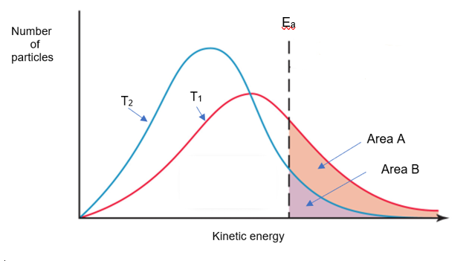
Which of the following statements concerning this information is correct?

a) Temperature T₁ is lower than temperature T₂.
b) The reaction rate at T₂ is greater than at T₁ because a greater area of the curve is to the left of the dotted line.
c) Adding a catalyst would move the dotted line to the right.
d) At temperature T₁, the number of particles with energy greater than the activation
energy is given by area A plus area B.

10. Which of the following statements correctly explains why a reaction is endothermic?

a) More energy is released when breaking reactant bonds than is absorbed when
making product bonds.
b) More energy is absorbed when breaking reactant bonds than is released when
making product bonds.
c) Less energy is absorbed when breaking reactant bonds than is released when making product bonds.
d) Less energy is released when breaking reactant bonds than is absorbed when making product bonds
Section Two: Short answer (37 Marks)

This section has six (6) questions. Answer all questions. Write your answers in the spaces provided.
Suggested working time: 40 minutes.
_________________________________________________________________________

Question 11 (5 marks)

Complete the following table by writing either the name or formula for each substance.

Name | Formula
 | BaSO₄
 | N₂F₄
sodium sulfide
 | SnO
magnesium hydroxide

Question 12 (5 marks)

a) Balance the following equations. (2 marks)

(i) ____Aℓ (s) + ____Cℓ₂ (g) → ____AℓCℓ₃ (s)

(ii) ____Ca(OH)₂ (aq) + ____HBr (aq) → ____CaBr₂ (aq) + ____H₂O (ℓ)

b) Write a balanced chemical equation for phosphine PH₃ (g) burning in oxygen gas to
form water vapour and solid phosphorus pentoxide. (3 marks)

____________________________________________________________________

____________________________________________________________________

____________________________________________________________________

Question 13 (7 marks)

a) Determine the number of moles of each element present in 3.00 moles of CH₃COOH.
(3 marks)

b) (i) Calculate the molar mass of CuCO₃. (1 mark)

(ii) Calculate the number of moles of CuCO₃ in 60.55 grams. (1 mark)

(iii) Determine the mass of oxygen in 60.55 grams of CuCO₃. (2 marks)

Question 14 (5 marks)

Carbon dioxide was prepared by a student in the laboratory by reacting sulfuric acid with a sample of potassium hydrogencarbonate. The equation for the reaction is:

2KHCO₃ (s) + H₂SO₄ (aq) → 2CO₂ (g) + 2H₂O (ℓ) + K₂SO₄ (aq)

If 24.70 grams of potassium hydrogencarbonate is reacted with excess sulfuric acid, determine the mass of K₂SO₄ formed.

Question 15 (6 marks)

In the lab, zinc granules react fairly slowly with dilute hydrochloric acid according to the following balanced equation:

Zn (s) + 2HCℓ (aq) → ZnCℓ₂ (aq) + H₂ (g)

State two ways that the rate of this reaction could be increased and explain how these changes increase the rate.

_________________________________________________________________________

_________________________________________________________________________

_________________________________________________________________________

_________________________________________________________________________

_________________________________________________________________________

_________________________________________________________________________

_________________________________________________________________________

_________________________________________________________________________

_________________________________________________________________________

_________________________________________________________________________

_________________________________________________________________________

_________________________________________________________________________

Question 16 (9 marks)

Nitrogen reacts with oxygen to form nitrogen monoxide according to the following equation.

N₂(g) + O₂(g) → 2NO(g) ΔH = +56 kJ/mol E_{a} = 140kJ

- This reaction is an exothermic / endothermic. (Circle one). (1 mark)

- Draw a correctly scaled energy profile diagram for this reaction. Indicate reactants,
products, change in enthalpy and activation energy on the diagram. (6 marks)

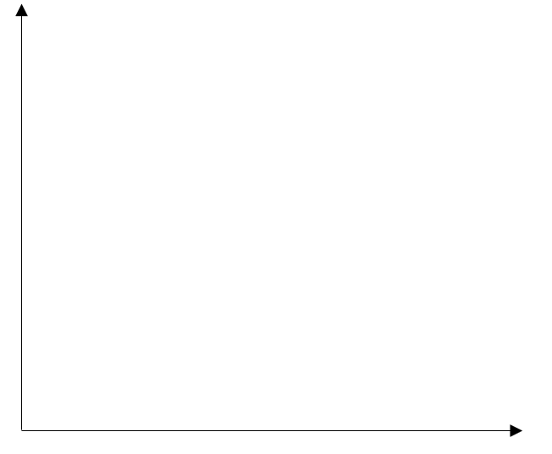

c) Indicate using a dotted line on the energy profile diagram above how the diagram would change if a catalyst was used and explain why this changes the diagram.
(2 marks)

____________________________________________________________________

____________________________________________________________________

____________________________________________________________________

____________________________________________________________________

End of Test

